

SCHOOL OF COMPUTER SCIENCE
AND ARTIFICIAL INTELLIGENCE
DEPARTMENT OF COMPUTER SCIENCE

Assignment Type: Lab
Academic Year:2025-2026
Course Coordinator Name:- Dr Jagjit Singh Dhatterwal
STUDENT NAME:-Pentapuri yeshwanth
ENROLLMENT NUMBER:-2403A51l39
SUBJECT NAME:- Blockchain Engineering
COURSE CODE:-23CS201PE401
YEAR/SEM :- III/II
BATCH:-52

TASK
Assignment submission starts from here

Code:-

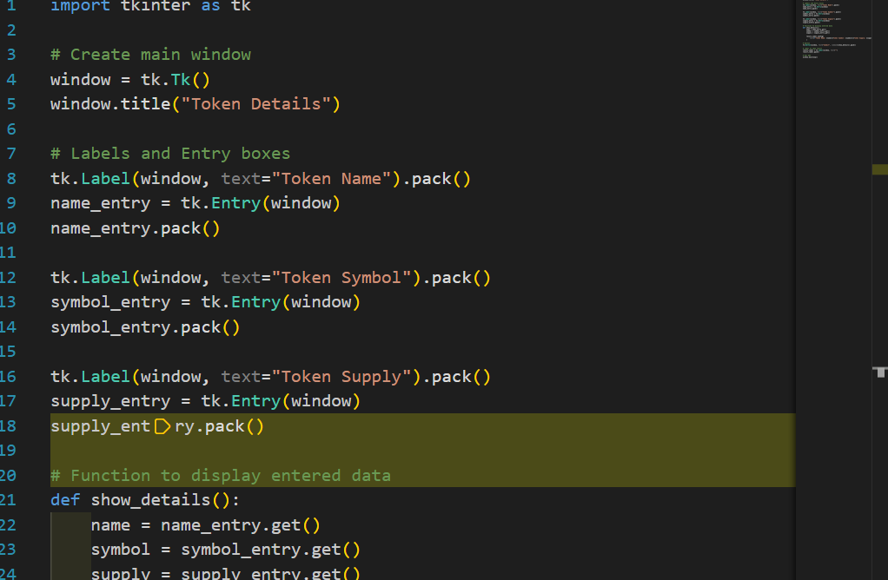

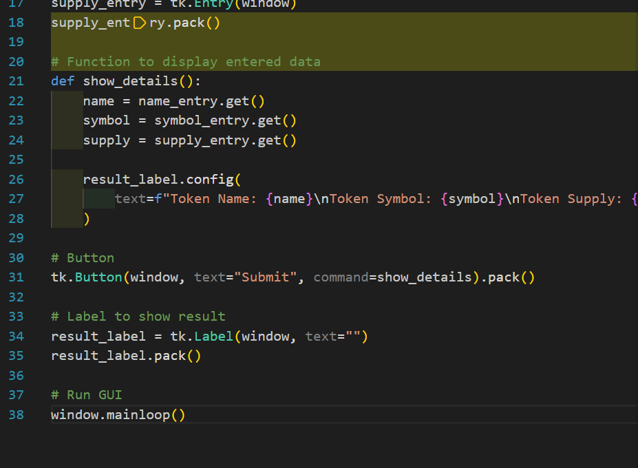

Output:-





